Title
The title must be the same as you previously submitted for the final program. Do not type in capital letters only. If you want to change the title of your presentation and your paper, please inform us by at the latest.

Author(s) Name(s) and Affiliations(s)
List the author’s full name and those of any co-authors. Please follow the example: R. Smith, J. Schmitz, Company/Institution/University 1, Country; P. Miller, S. Winter, Company/Institution/University 2, Country; etc. Do not type in capital letters only.
Only speakers will be offered a reduced conference fee; please use only the speaker platform to register. Co-authors must register as standard conference participant if they want to participate.

Contact data
Please name a contact to whom the reader can direct questions about the paper (Name, Company, Address, Phone, Fax, Email).

Summary
The Summary must state the main object, scope and findings of the work in no more than 300 words.

Key Words
Key Words will be used to help the reader identify the main topics your paper is dealing with. A list of six to eight Key Words are required to accompany the summary.
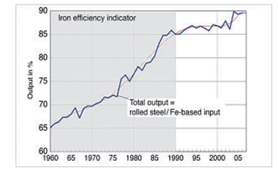

Introduction
The introduction should give a brief overview of any preconditions, procedures and problems presented in the paper.

Tables and Figures
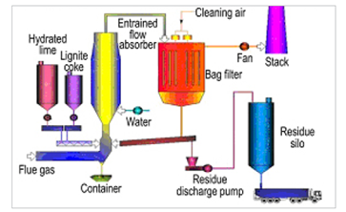
Each figure and table must have a caption typed directly below it such as Figure 1 and 2
Figure 1: End-of-pipe solution by fabric filter technology at Rogesa

Figure 2: Iron efficiency indicator of the German steel industry

Conclusion
A conclusion should briefly review the most significant information and conclusions of the paper. A well-written conclusion should be no more than one paragraph.

Abbreviations
All abbreviations used in the paper should be explained in a table.

Acknowledgments
An acknowledgment is optional; however, if one is included it should be brief and written in the first person, using “I” or “we”.

References
References should be cited in the following manner:
[1] Johnson, M.; Argyris, R.; MCGee, T.: Iron ores and coke supplies for the German steel industry; Int. J. Machine Tool Res., 25-50 (2009), P. 30
[2] Goodfellows, H. D.; Pozzi, M.: Coke reactivity in steelmaking; MPT, 2006, No. 6, P. 24-30

Appendix
An appendix is optional; however, if one is included it should be related to one topic and each topic should form a separate appendix.

Formatting Instructions
Once you receive your username and password please log-in to your personal area.
Please check and complete your submitted data. Submit your paper as a Word and PDF file (with complete incorporated pictures). Please make sure that you have the copyright of all pictures. The organizer is not liable for any claims.
The maximum space available is 10 pages.
The paper will be published in electronic form; so please ensure good quality for the pictures, tables and diagrams. All graphics can be in color.
Please type left-aligned; the text must be arranged in two columns.
The limit for your Word and PDF file is 20 MB.
Due to the enormous number of papers, we are not able to proofread either the papers or the presentations. Please make sure that spelling and grammar are correct and that you followed the Guidelines for Authors / Speakers properly.
If the paper is not in the right format, we will not accept it. Papers submitted in the wrong format or after the deadline might not be published and the presentations deleted from the program.

Equations
Equations are set away from the text by a double space above and below the equation.

Copyright
Copyright of all material published in the 5th ESTAD 2021 Proceedings passes over to Jernkontoret.

